**VOLTA**

**VOLUME AND TOPOGRAPHY AUTOMATION**

**VERSION 1.2 USER MANUAL**

William James

University of Leeds

gy06whmj@leeds.ac.uk

**Table of Contents**

1 Introduction 2

2 System Requirements 2

3 VOLTA set up 3

3.1 Adding the VOLTA toolbox 4

4 Generating centrelines 4

4.1 Manually generating centrelines 6

5 Estimating ice thickness 7

5.1 Interpreting the ice thickness results 8

6 Input data: standards and requirements 10

6.1 File formats 10

6.2 DEM 11

6.3 Glacier Outlines 11

6.4 Glacier Centrelines 11

# Introduction

VOLTA (Volume and Topography Automation) is a research and educational tool for estimating ice thickness and bed topography of glaciers using GIS datasets. VOLTA is written in the Python scripting language and executed via a graphical user interface (GUI) in ArcGIS in the same manner as any standard geoprocessing tool. It is available for download for academic research purposes via <https://github.com/williamjames/volta>. For further details on the development of VOLTA, please refer to the accompanying research paper.

# System Requirements

* PC running ArcGIS 10.3.1 for desktop or above (older versions may work but are not supported)
* SciPy Stack for Python

VOLTA requires the SciPy Stack and associated Python modules to run correctly. Whilst this is installed automatically with a standard install of ArcGIS 10.3.1, it may not be on custom installs or with earlier versions of ArcGIS. To check if the SciPy Stack is installed and integrated with ArcGIS, open a new ArcMap document and click the Python window button (figure 1a). Once the command window is open, type ‘import scipy’ on the first line and press return.

If a new primary prompt (>>>) is returned (figure 1a), SciPy is correctly installed and no further action is necessary. If the error ‘*No module named scipy’* is returned (figure 1b), installation of SciPy is required.

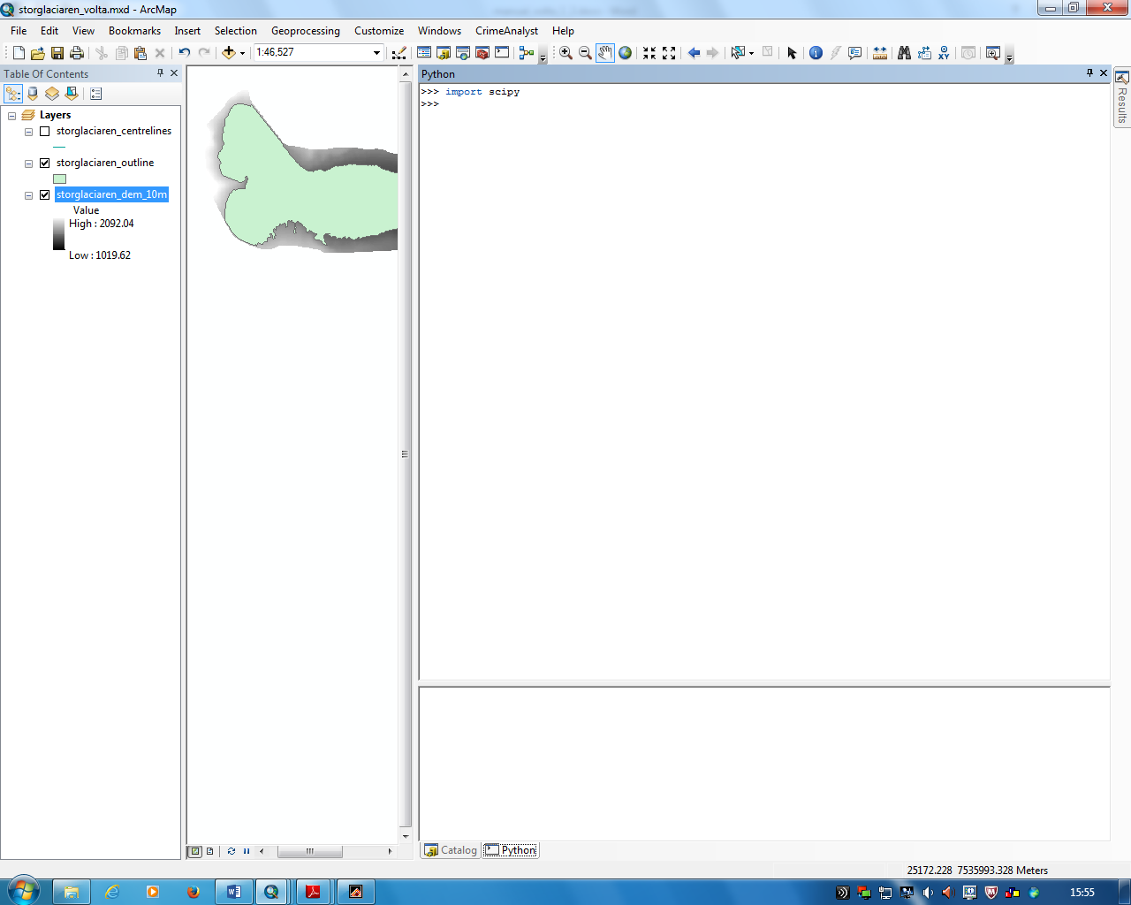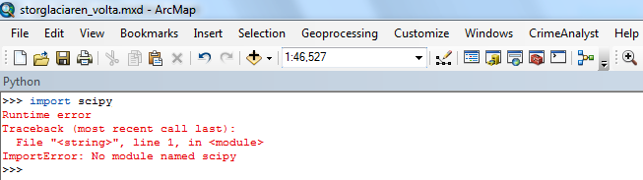

a)

b)

**Fig. 1a)** Location of Python window button in ArcMap and example of message returned with successful SciPy integration. **b)** Error message returned if SciPy is not successfully installed/integrated.

If installation is required, download and unzip the SciPy Stack [scipy-0.16.0-win32-superpack-python2.7.zip](https://github.com/williamjames/volta/blob/master/scipy-0.16.0-win32-superpack-python2.7.zip) on the VOLTA github site <https://github.com/williamjames/volta>**.** Alternatively the SciPy stack may be downloaded directly from [https://www.scipy.org](https://www.scipy.org/)**.** Once unzipped, run installer: scipy-0.16.0-win32-superpack-python2.7.exe and follow onscreen instructions. If multiple installation of Python are present, make sure to select the Python installation used by ArcGIS (figure 2).

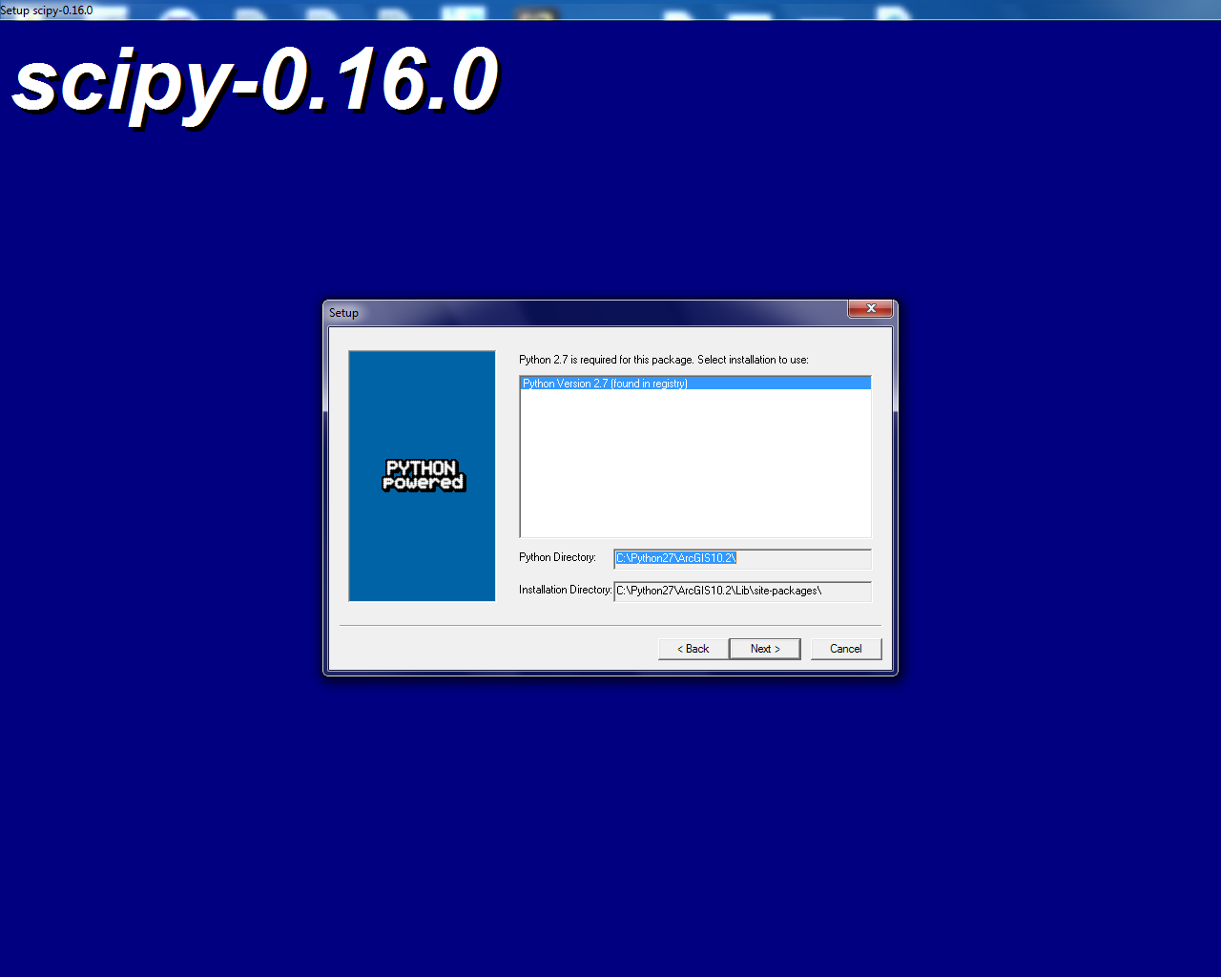

**Fig. 2** Setting the SciPy installation to the Python version used by ArcGIS

The SciPy stack should now be installed and integrated correctly with ArcGIS. Check for successful installation using the method described previously.

Further information on integrating ArcGIS and SciPy can be found at: <http://www.esri.com/esri-news/arcuser/winter-2015/integrating-arcgis-and-scipy>

# VOLTA set up

The VOLTA package can be downloaded via the [volta_1_2.zip](https://github.com/williamjames/volta/blob/master/volta_1_2.zip) file on VOLTA github site <https://github.com/williamjames/volta>

The package contains the VOLTA toolbox, associated Python scripts and sample test data:

**volta_1_2.tbx**: ArcGIS toolbox file

**volta_1_2_test_data.gdb**: An ArcGIS geodatabase containing example data (glacier outlines and DEM’s) for Patagonia and Storglaciären

**patagonia_sample_volta.mxd:** sample map document for Patagonia region

**storglaciaren_volta.mxd:** sample map document for Storglaciären

**volta_1_2_centreline.py**: Python script code for glacier centreline production

**volta_1_2_thickness.py:** Python script code for ice thickness estimation

The following guide shows how VOLTA is executed for the ‘storglaciaren_volta.mxd’ sample dataset included in the VOLTA package. The process is the same for any project, with details of data requirements and preparation for new projects provided later in this document. It is recommended VOLTA is initially trialled on the included sample datasets (storglaciaren_volta.mxd and patagonia_sample_volta.mxd) to ensure correct functionality and performance before running on user specified data.

## Adding the VOLTA toolbox

VOLTA is executed as a standard ArcGIS geoprocessing toolbox in ArcMap. To add the toolbox, open an ArcMap document, click the toolbox button (figure 3), right click in the ArcToolbox window and select ‘Add Toolbox’. Navigate to the ‘volta_1_2’ folder downloaded from the VOLTA github site and select the toolbox file (‘volta_1_2.tbx’). Volta_1_2 will now appear in the list, containing two tools: a centreline generation tool (‘volta_1_2_centreline’) and a thickness estimation tool (‘volta_1_2_thickness’), (figure 4).

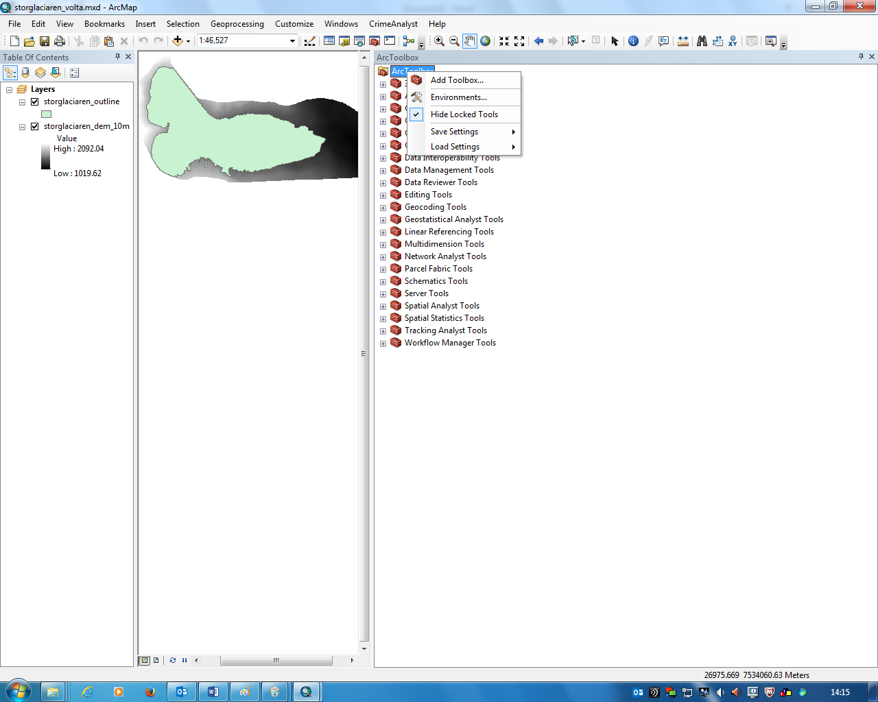

**Fig. 3** Location of ArcToolbox button in ArcMap and dialogue box for adding new toolbox

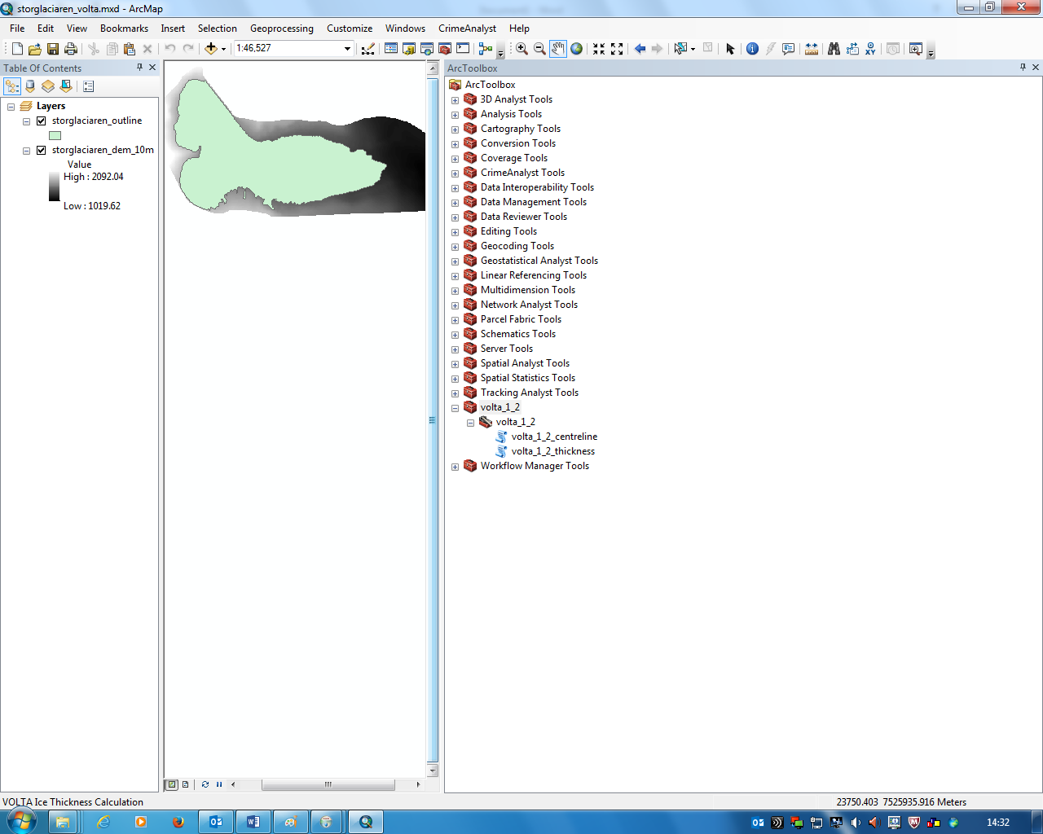

**Fig. 4** VOLTA toolbox loaded in ArcMap

# Generating centrelines

VOLTA initially estimates ice thickness values along a network of glacier centrelines, which may be automatically derived using the ‘volta_1_2_centreline’ tool. For full details of the centreline generation process, please refer to the full VOLTA research paper.

To generate centreline(s), open the ‘volta_1_2_centreline’ tool and specify the parameters as shown in figure 5 and described below. The examples shown are for the Storglaciären test dataset included in the VOLTA package but the process is the same for other user specified projects.

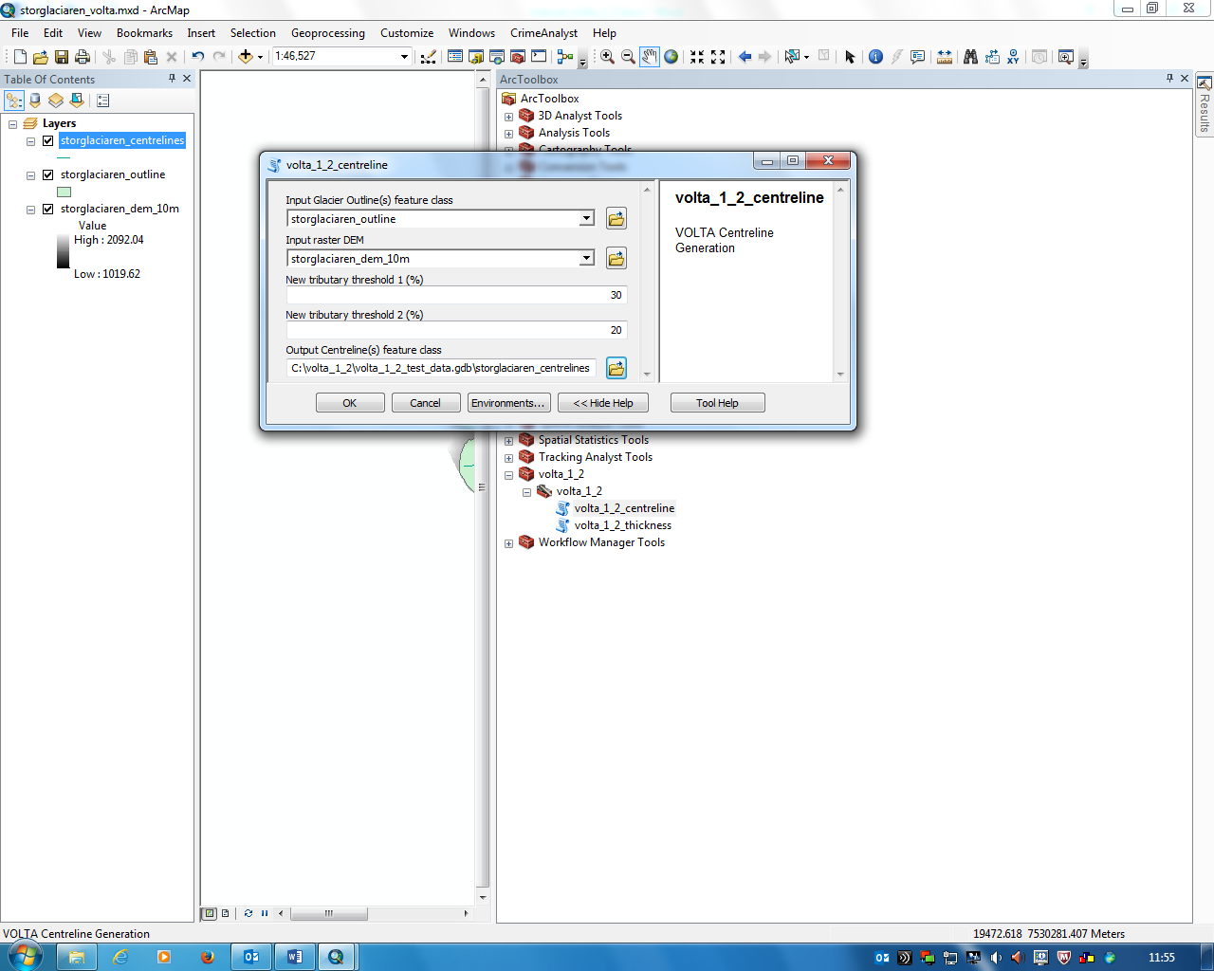

**Fig. 5** VOLTA centreline tool GUI with parameters for Storglaciären test dataset

**Input glacier outline(s) feature class:** Select the glacier outlines layer from the drop-down menu

**Input raster DEM:** Select the ice surface DEM from the drop-down menu

**New tributary threshold 1 (%):** Set by default at 30% but can be altered if required. Relates to the generation of secondary centrelines by specifying the minimum increase in glacier area needed to define a new branch during the iterative ‘upstream area’ calculations. Increasing the value may lead to less secondary centrelines being produced as iterative increases in area will need to be larger before a new branch is defined. Modifying this parameter may produce more reliable centrelines if the initial model run produces unrealistic centrelines. See the full VOLTA research paper for further information.

**New tributary threshold 2 (%):** Set by default at 20% but can be altered if required. Relates to the generation of secondary centrelines by defining a minimum overall area for a new branch in relation to the overall glacier size. Increasing the value may lead to less secondary centrelines being produced as branches with smaller areas may be excluded. Modifying this parameter may produce more reliable centrelines if the initial model run produces unrealistic centrelines.

**Output Centreline(s) feature class:** Specify the location and filename for output centreline. This should be in the form of a file geodatabase feature class stored in an ArcGIS file geodatabase – in the example provided (figure 5) the feature class is stored in the geodatabase provided as part of the VOLTA package (volta_1_2_test_data.gdb). Whilst possible, outputting centrelines as a shapefile (.shp) in a standard folder is not recommended, especially for larger datasets. For instructions for creating a new file geodatabase, please refer to section 6.1.

Once the parameters have been entered, run the tool by clicking OK. A dialogue box will update the progress of the tool, with the final output for the Storglaciären example shown in figure 6.

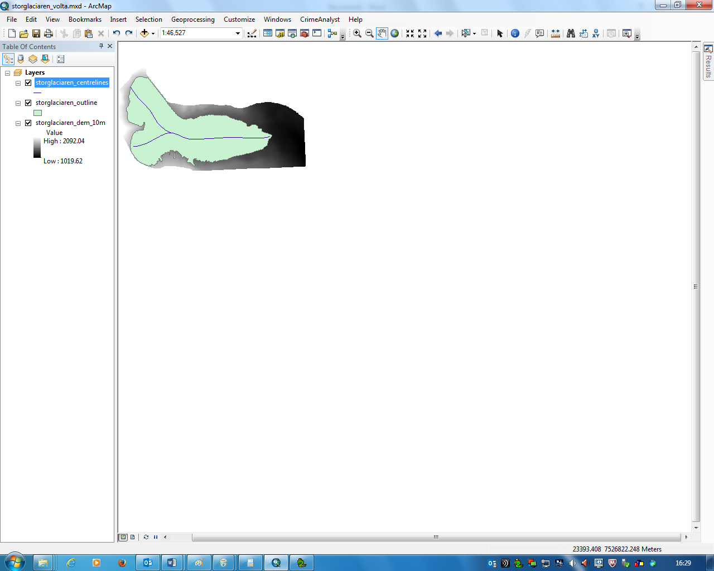

## 

**Fig. 6** VOLTA generated centrelines for the Storglaciären test dataset

## Manually generating centrelines

In some cases, the automated centreline production tool may fail to generate satisfactory centrelines, often due to poor quality glacier outlines/DEM or unusual/complex glacier outlines. In a test scenario VOLTA was able to generate acceptable centrelines in 91 % of cases. For further details of centreline generation and potential issues, please refer to the full VOLTA research paper.

If VOLTA fails to generate acceptable centrelines, the process may be completed using alternative automated/semi-automated techniques (e.g. Kienholz et al. 2014) or by manually tracing a line from the highest point of each branch to the lowest, linking the points of maximum surface curvature (Paul et al. 2010). This can be achieved in ArcGIS using a standard editing procedure, making sure the following rules are observed:

* Centrelines must not cross (but can ‘touch’) the boundary of the glacier outline they are being derived for, including any nunataks.
* If multiple centrelines are created for a particular glacier outline, each individual centreline should still run to the terminus. This often means that multiple centrelines will share identical geometry after merging.
* Centrelines should be saved or exported as a file geodatabase feature class stored in an ArcGIS file geodatabase. Whilst possible, saving centrelines as a shapefile (.shp) in a standard folder is not recommended, especially for larger datasets.

# Estimating ice thickness

Once centrelines have been generated, ice thickness values can be estimated using the ‘volta_1_2_thickness’ tool. The tool initially estimates ice thickness at points along the centreline(s) and subsequently interpolates a fully distributed ice thickness raster within the boundaries of the glacier outlines supplied. To estimate ice thickness values, open the ‘volta_1_2_thickness’ tool and specify the parameters as shown in figure 7 and described below. The examples shown are for the Storglaciären test dataset included in the VOLTA package but the process is the same for other user specified projects.

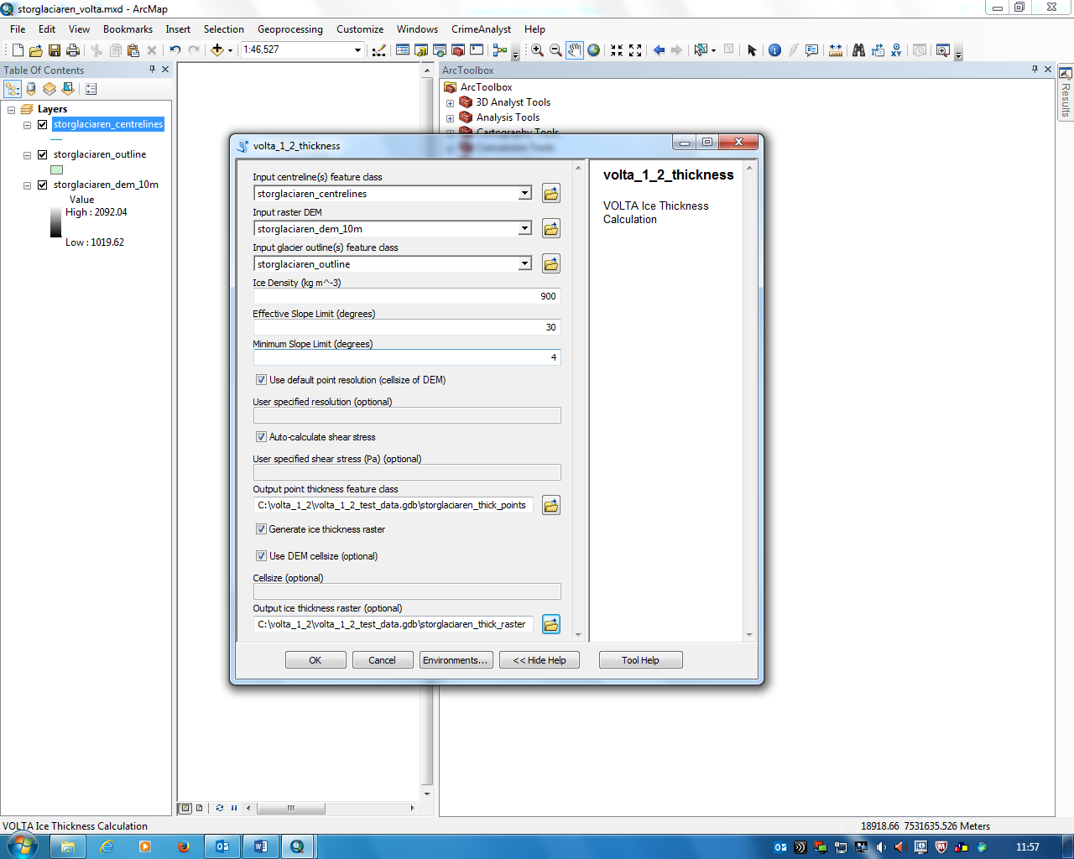

**Fig.7** VOLTA ice thickness tool GUI with parameters for Storglaciären test dataset

**Input centreline(s) feature class:** Select the centreline layer from the drop-down menu

**Input raster DEM:** Select the ice surface DEM from the drop-down menu

**Input glacier outline(s) feature class:** Select the glacier outlines layer from the drop-down menu

**Ice Density:** Set by default at 900 km m-3, but can be altered if required

**Effective Slope Limit (degrees):** Set at 30o but can be altered if required. This threshold determines at what limit steep parts of the valley wall are excluded from the width calculation. See the full VOLTA research paper for further information.

**Minimum Slope Limit (degrees):** Set at 4o by default but can be altered if required. This threshold stops unrealistic ice thickness values being estimated in very flat regions. See the full VOLTA research paper for further information.

**Use default point resolution (cellsize of DEM):** Enabled by default. If this option is enabled, initial points for ice thickness estimation will be placed on the centreline network at a spacing equal to the resolution of the DEM

**User specified resolution:** Only available if ‘Use default point resolution (cellsize of DEM)’ parameter is unchecked. Specify a value for the spacing between initial ice thickness estimation points. Specifying a larger value may improve processing time.

**Output point thickness feature class:** Specify the location and filename for output ice thickness estimation points. This should be in the form of a file geodatabase feature class stored in an ArcGIS file geodatabase – in the example provided (figure 7) the feature class is stored in the geodatabase provided as part of the VOLTA package (volta_1_2_test_data.gdb). Whilst possible, outputting centrelines as a shapefile (.shp) in a standard folder is not recommended, especially for larger datasets. For instructions for creating a new file geodatabase, please refer to section 6.1.

**Generate ice thickness raster:** Enabled by default. If this option is enabled, an ice thickness raster will be created. Disabling this option may be useful if only the centreline point estimates are required.

**Use DEM cellsize:** Only available if ‘Generate ice thickness raster’is enabled. If checked the output ice thickness raster will be of the same resolution as the input DEM

**Cellsize:** Only available if Use DEM cellsize is disabled. Specify a value for the resolution of the output ice thickness raster.

**Output ice thickness raster:** Only available if ‘Generate ice thickness raster’is enabled. Specify the location and filename for output ice thickness raster. This should be in the form of a file geodatabase raster dataset stored in an ArcGIS file geodatabase – in the example provided (figure 7) the raster is stored in the geodatabase provided as part of the VOLTA package (volta_1_2_test_data.gdb). For instructions for creating a new file geodatabase, please refer to section 6.1.

## Interpreting the ice thickness results

The VOLTA ice thickness estimation tool outputs two files – point thickness estimates along the centreline and (optionally) an ice thickness raster (Fig 8). The ice thickness raster reports thickness values in relation to the input surface DEM for the regions covered by the glacier outline(s).A value of 0 denotes no ice coverage and larger values indicating greater ice thickness. The bed elevation (and ‘bed DEM’) can consequently be calculated by simply subtracting the thickness raster from the DEM (using the raster calculator tool in ArcGIS) if required.

The raw point thickness estimates are output as a File Geodatabase Feature class (figure 8), with additional details available in the associated attribute table (figure 9). To access this table, right click on the points layer in the table of contents and select ‘Open Attribute Table’.

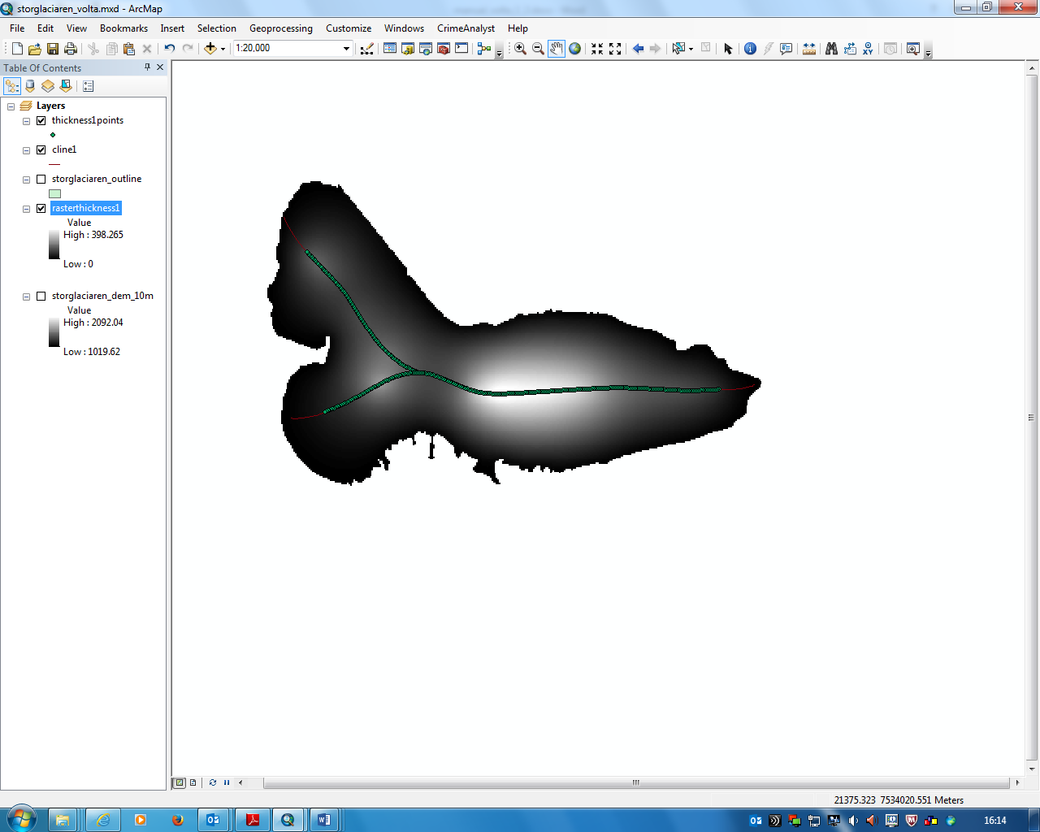

**Fig. 8** VOLTA outputs for Storglaciären: ice thickness raster and centreline thickness points. Lighter shading represents thicker ice.

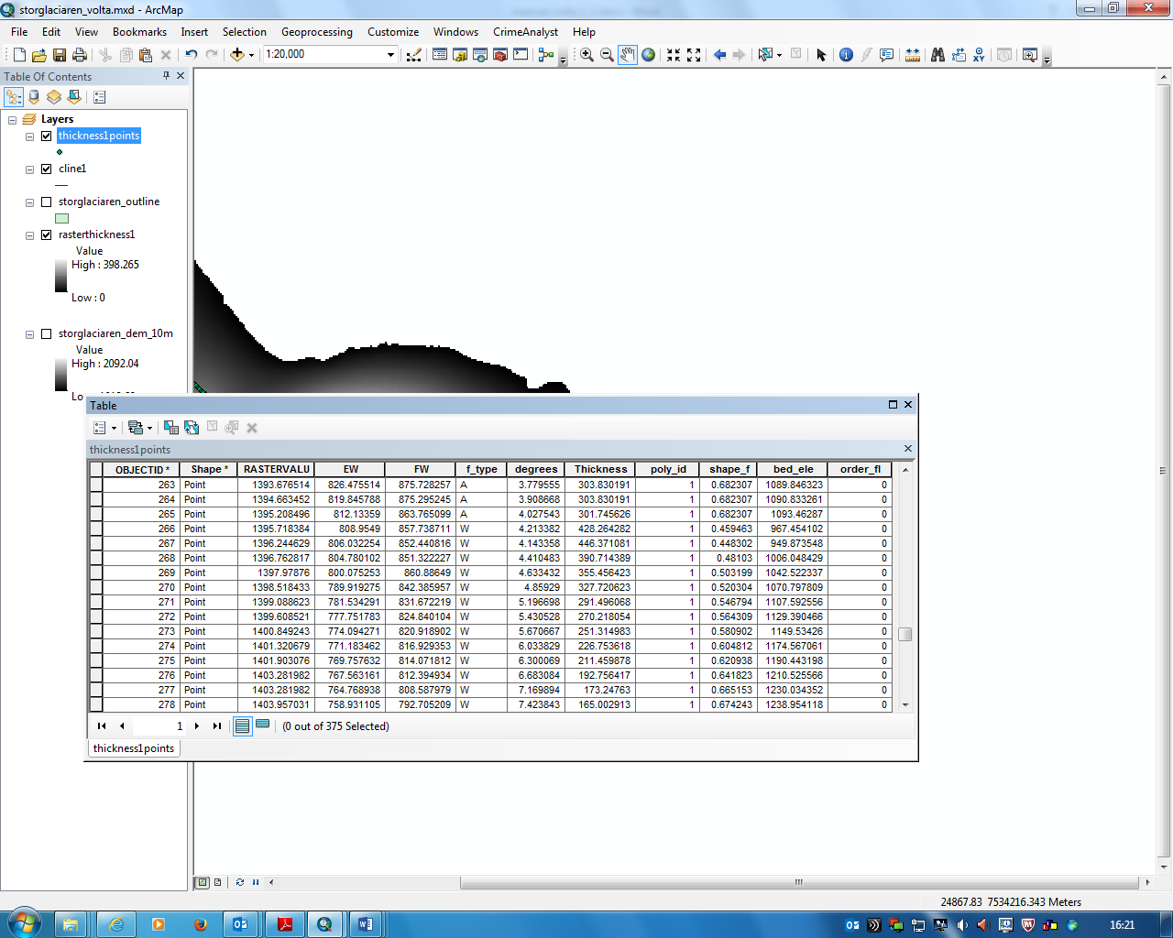

**Fig. 9** Attribute table for ice thickness estimation points

0Fields included in the attribute table are:

**OBJECTID:** Default ArcGIS field - Unique reference ID for each point

**Shape**: Default ArcGIS field – type of feature, in this case ‘Point’

**RASTERVALU:** DEM surface elevation

**EW:** Effective width – the glacier width at the specified point, not including any regions above the ‘Effective Slope Threshold’ limit defined in the input dialogue box

**FW:** Full width – the full glacier width at the specified point

**f_type:** Field to describe which ice thickness estimation method has been used – W denotes the independent width at this point has been used whilst A denotes the tributary averaged value has been used. For information regarding the different methods of thickness calculation, and the conditions upon which VOLTA uses each, please refer to the accompanying research paper.

**Degrees:** The centreline surface slope at the specified point. For more information on the distance over which the slope is calculated, please refer to the accompanying research paper.

**Thickness:** The estimated ice thickness at the specified point. A value of 0 represents no ice whilst larger values represent thicker ice.

**Poly_id:** Identifies which glacier outline the specified is within. Useful when multiple outlines are used.

**shape_f:** The calculated shape factor (f) used in the ice thickness estimation calculations. For more information on the f factor and its calcualtion please refer to the accompanying research paper

**bed_ele:** The elevation of the glacier bed at the specified point. Automatically calculated as the DEM surface elevation (RASTERVALU field) minus the estimated ice thickness.

**Order_fl:** The ‘order’ of the centreline upon which the specified point is on. The primary centreline (with the largest altitudinal extent) has a value of 0, with the secondary centreline (second greatest altitudinal extent) has a value of 1 and henceforth.

# Input data: standards and requirements

## File formats

For optimal performance and stability, all input and output files should be stored in an ArcGIS geodatabase as either a feature class (vector files: centrelines, outline polygons and ice thickness points) or as a file geodatabase raster (DEM, ice thickness raster). Feature classes in a geodatabase have many advantages compared to shapefiles, for more information please refer to:

http://pro.arcgis.com/en/pro-app/tool-reference/appendices/geoprocessing-considerations-for-shapefile-output.htm

To create a new file geodatabase in ArcGIS, open the catalogue window in ArcMap, right click in the desired location and select new > File Geodatabase (figure 10a). If input files (glacier outlines, DEM) are in an alternative format (e.g. shapefiles), these may be converted by right clicking on the layer in the table of contents and selecting Data > Export Data (figure 10b).

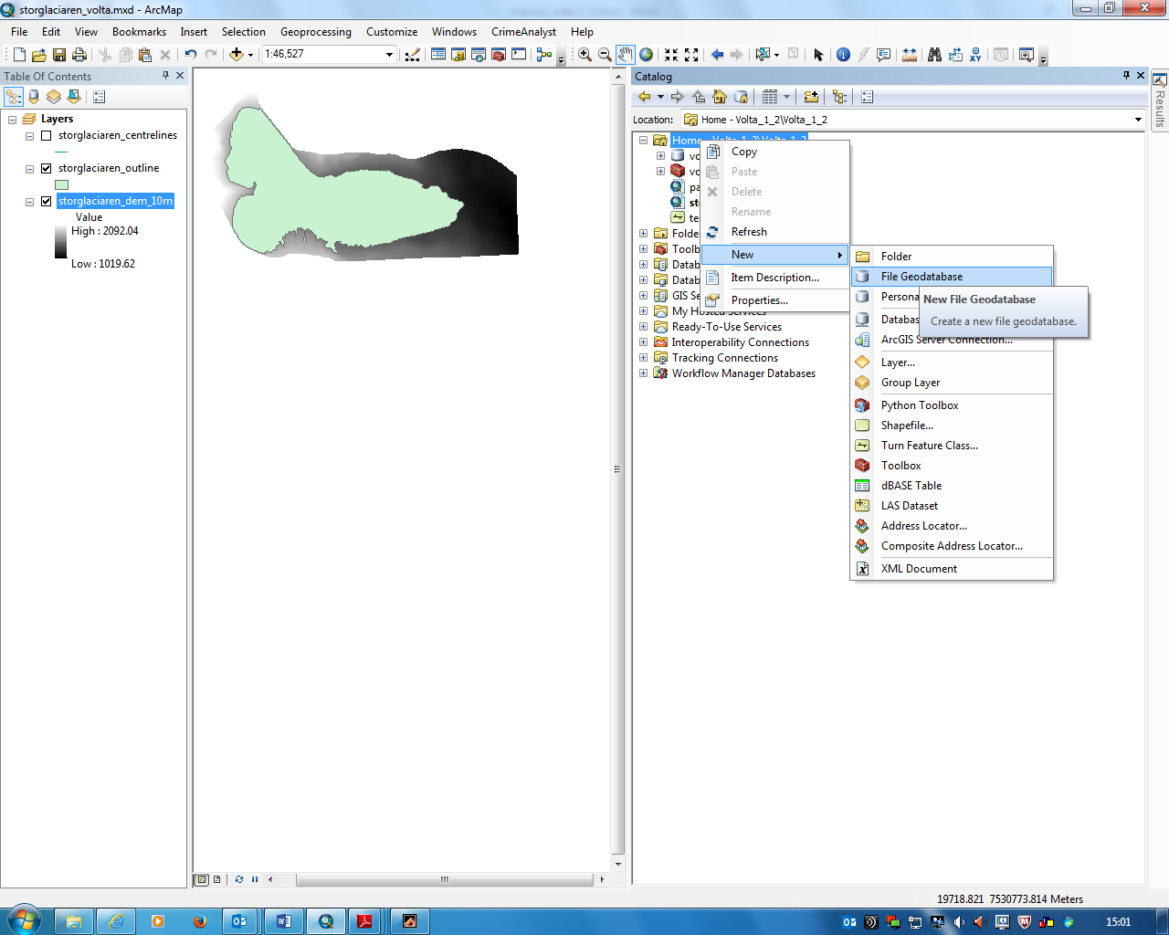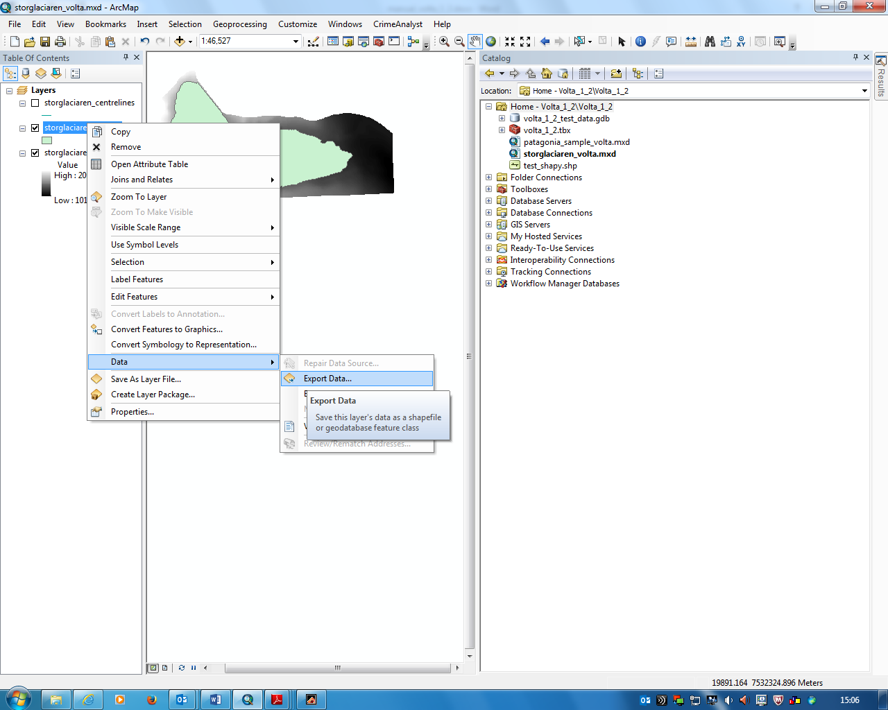

a)

b)

**Fig 10a)** Creating a new File Geodatabase via the catalogue window in ArcMap. **b)** Exporting an existing shapefile to a File Geodatabase.

## DEM

The DEM should be in a Cartesian XY co-ordinate system, cover the entire area delineated by the glacier outline polygons and should be checked for irregularities/artefacts. Smoothing the initial DEM may help to remove any imperfections and filling of sinks may help to improve centreline generation. There is no minimum required resolution, although sufficient detail of glacier surface features is required for accurate thickness estimates.

## Glacier Outlines

Glacier outlines should be in a polygon format, with a separate feature for each glacier. Outlines should include genuine nunataks as ‘holes’, although careful checking should be carried out for spurious holes as ice thickness may be erroneously estimated as zero at these locations. Outline polygons should delineate individual glaciers separated by ice divides where appropriate, rather than showing ‘glacier complexes’ (Figure 11). A technique for manually identifying ice divides is demonstrated in the full VOLTA research paper if required.

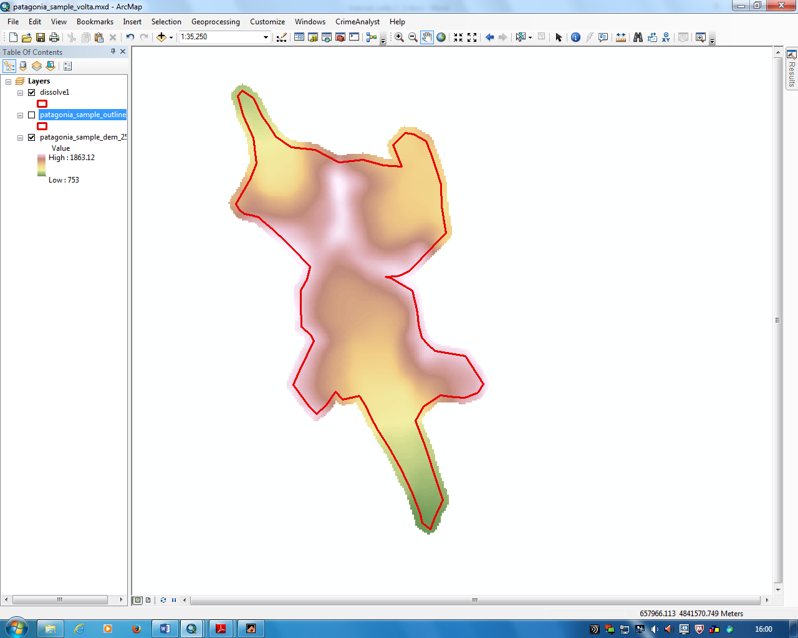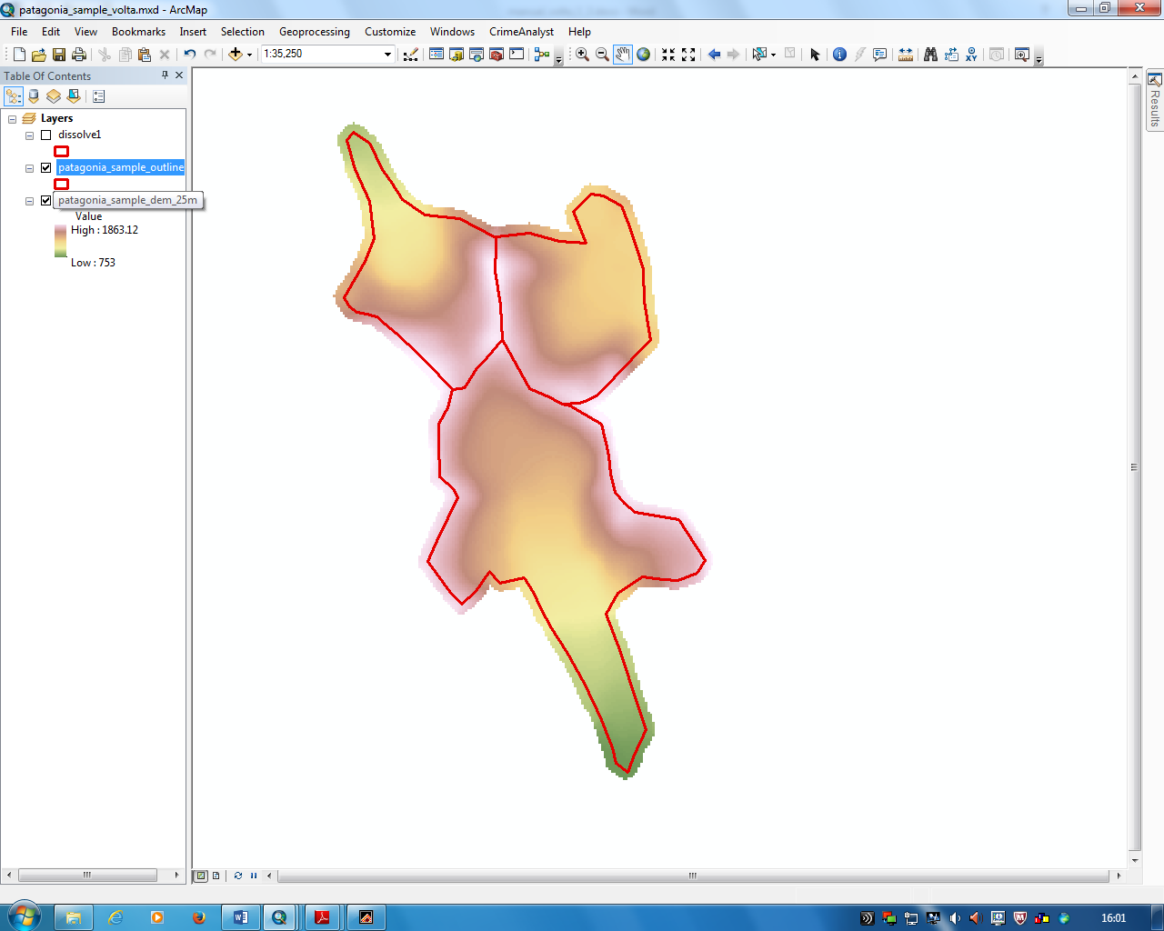

**Fig. 11** Examples of correctly formatted glacier outlines with ice-divides included (left) and incorrectly formatted outlines delineating ‘glacier complexes’.

## Glacier Centrelines

The centrelines automatically by VOLTA will be suitable for the ice thickness estimation tool. If using centrelines from an alternative source, please refer to the guidelines in section 4.1 regarding centreline requirements and standards.

**Reference List**

Kienholz, C. et al. 2014. A new method for deriving glacier centerlines applied to glaciers in Alaska and northwest Canada. *The Cryosphere,* **8**(2), pp.503-519.

Paul, F. et al. 2010. Recommendations for the compilation of glacier inventory data from digital sources. *Annals of Glaciology,* **50**(53), pp.119-126.